**LAPORAN KEGIATAN UJI KOMPETENSI**

**KEJURUAN SMK MAHARDHIKA BATUJAJAR**

**TAHUN PELAJARAN 2024-2025**

KOMPETENSI KEAHLIAN : Rekayasa Perangkat Lunak

KELAS : XII RPL 2

NAMA LENGKAP : Farell Maulidzan Latansyah

NIS : 2223.10.400

PAKET SOAL : 2

JENIS APLIKASI : Mobile

ALOKASI WAKTU : 8 jam

# 1. PENJADWALAN KEGIATAN

|  |  |  |  |  |  |  |  |  |  |  |  |  |  |  |  |  |  |  |  |  |  |  |  |  |
| --- | --- | --- | --- | --- | --- | --- | --- | --- | --- | --- | --- | --- | --- | --- | --- | --- | --- | --- | --- | --- | --- | --- | --- | --- |
| Kegiatan | Minggu 1 | | | Minggu 2 | | | Minggu 3 | | | | Minggu 4 | | | | Minggu 5 | | | | | Minggu 6 | | | | |
| 1 | 2 | 3 | 4 | 5 | 6 | 7 | 8 | 9 | 10 | | 11 | 12 | 13 | | 14 | 15 | 16 | 17 | | 18 | 19 | 20 |
| Analisis Soal |  |  |  |  |  |  |  |  |  |  | |  |  |  | |  |  |  |  | |  |  |  |
| Perancangan Sistem |  |  |  |  |  |  |  |  |  |  | |  |  |  | |  |  |  |  | |  |  |  |
| Perancangan DB |  |  |  |  |  |  |  |  |  |  | |  |  |  | |  |  |  |  | |  |  |  |
| Perancangan UI/UX |  |  |  |  |  |  |  |  |  |  | |  |  |  | |  |  |  |  | |  |  |  |
| Implementasi DB |  |  |  |  |  |  |  |  |  |  | |  |  |  | |  |  |  |  | |  |  |  |
| Implementasi UI/UX |  |  |  |  |  |  |  |  |  |  | |  |  |  | |  |  |  |  | |  |  |  |
| Implementasi Program |  |  |  |  |  |  |  |  |  |  | |  |  |  | |  |  |  |  | |  |  |  |
| Finalisasi Program |  |  |  |  |  |  |  |  |  |  | |  |  |  | |  |  |  |  | |  |  |  |
| Pengujian Program |  |  |  |  |  |  |  |  |  |  | |  |  |  | |  |  |  |  | |  |  |  |
| Hosting + Github |  |  |  |  |  |  |  |  |  |  | |  |  |  | |  |  |  |  | |  |  |  |
| Finalisasi Dokumentasi User Manual |  |  |  |  |  |  |  |  |  |  | |  |  |  | |  |  |  |  | |  |  |  |
| Finalisasi Projek UKK |  |  |  |  |  |  |  |  |  |  | |  |  |  | |  |  |  |  | |  |  |  |
| Dokumentasi |  |  |  |  |  |  |  |  |  |  | |  |  |  | |  |  |  |  | |  |  |  |

# 2. PERSIAPAN PERANGKAT KERAS

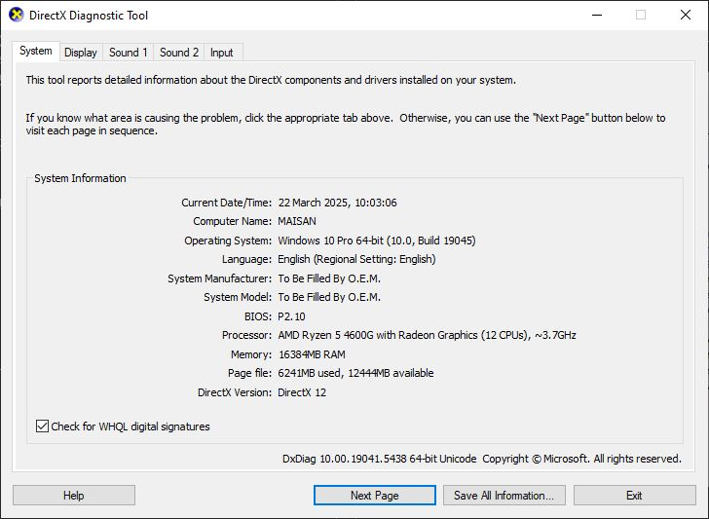

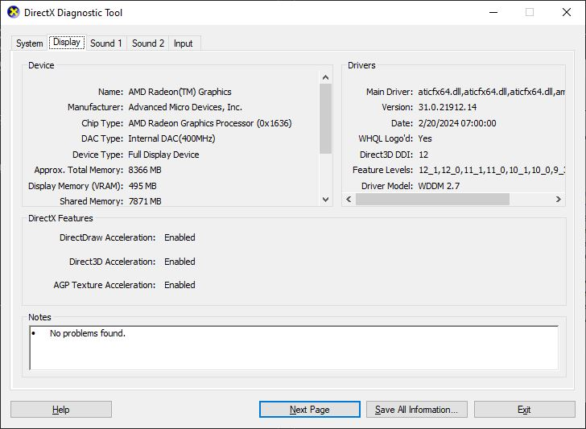

# 3. PERSIAPAN PERANGKAT LUNAK

# 4. PERANCANGAN ALGORITMA APLIKASI

Activity Diagram Login

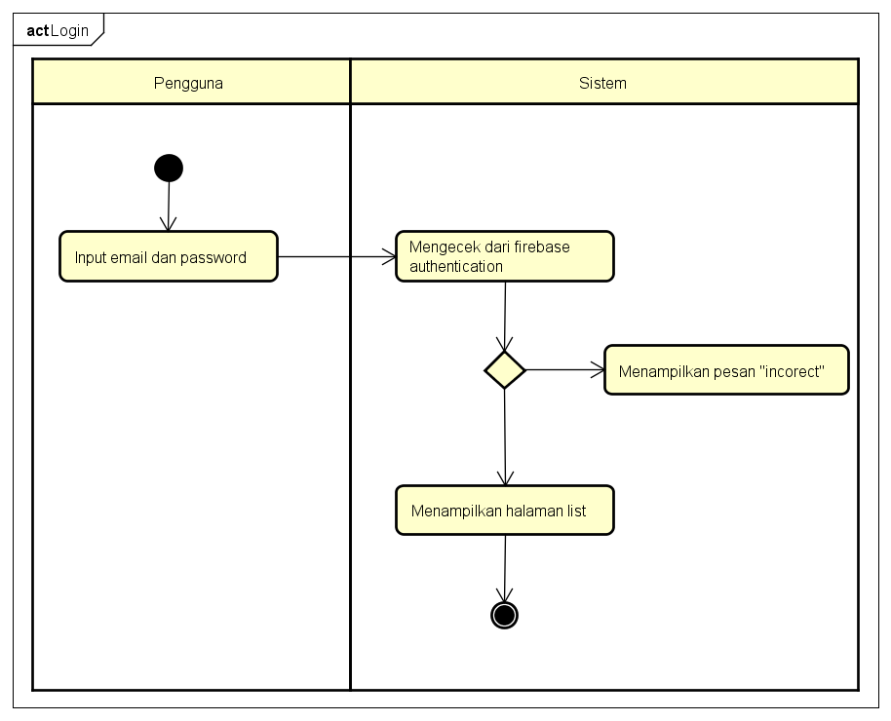

Activity Diagram Register

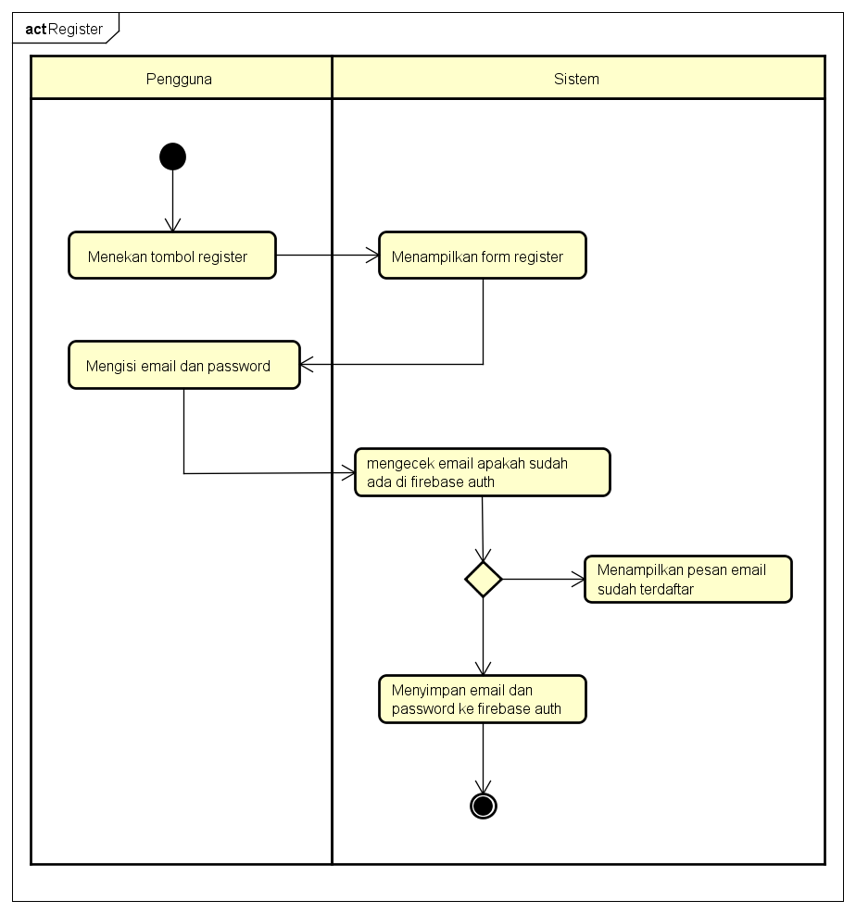

Activity Diagram Tambah List

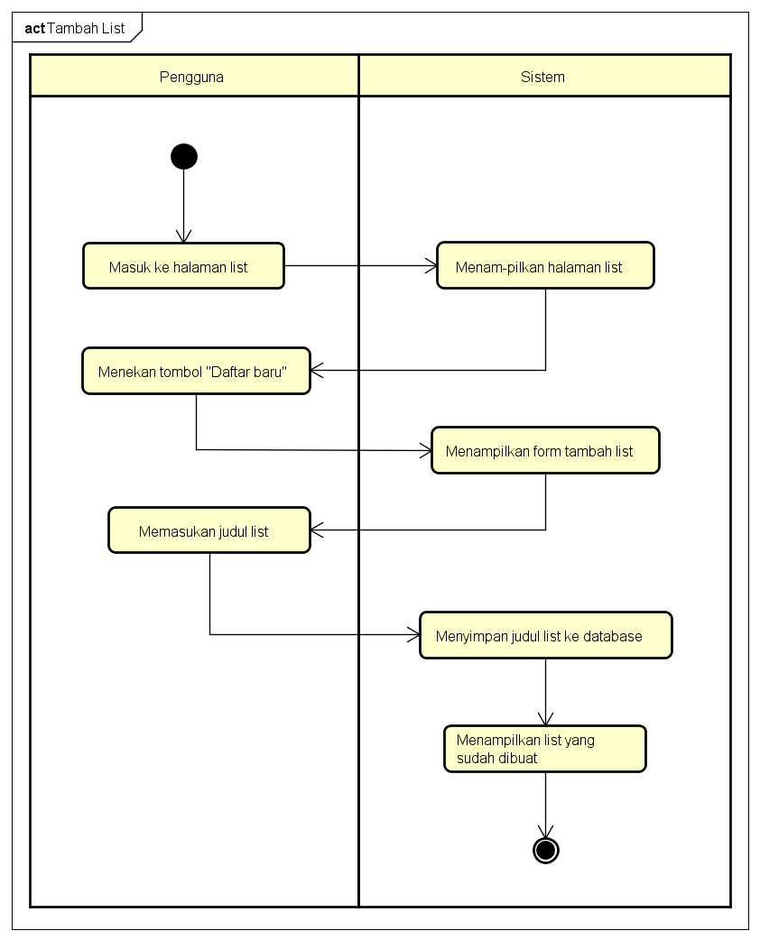

Activity Diagram Delete List

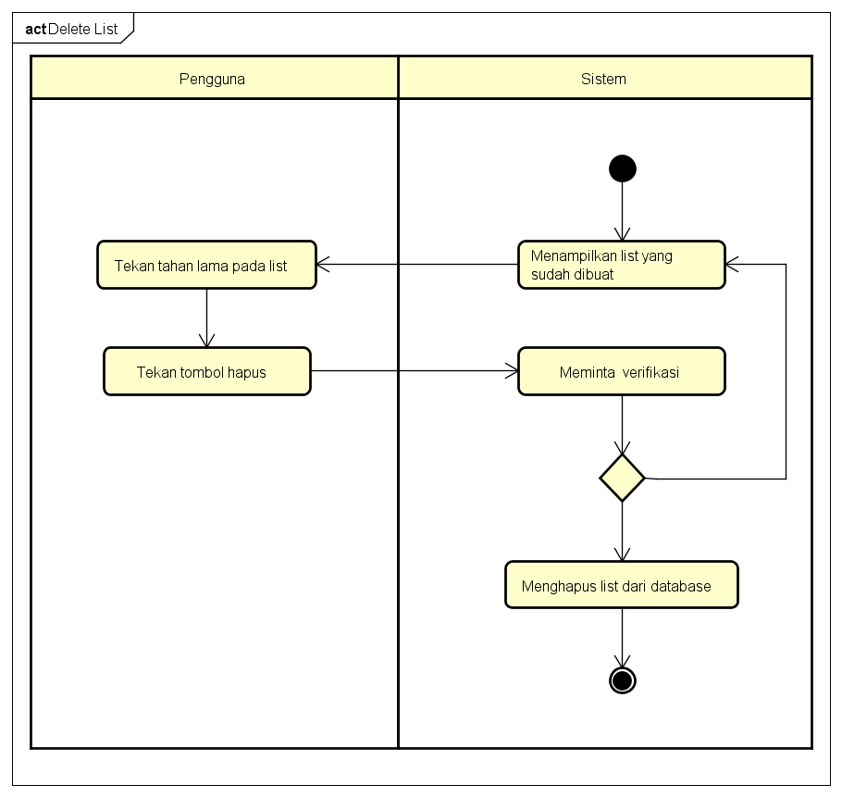

Activity Diagram Edit List

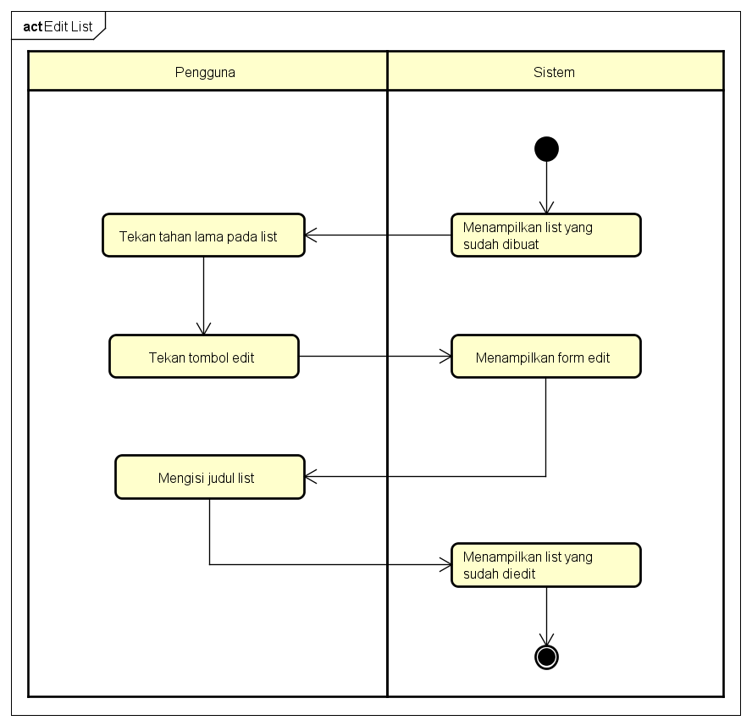

# 5. PERANCANGAN BASIS DATA

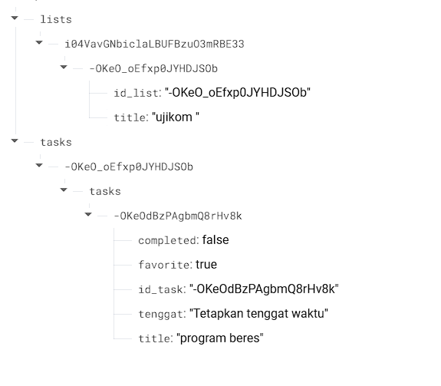

# 6. DUMMY DATA

Lists

|  |  |  |
| --- | --- | --- |
| User UID | id_list | title |
| i04VavGNbiclaLBUFBzuO3mRBE33 | -OKeO_oEfxp0JYHDJSOb | ujikom |

Tasks

|  |  |  |  |  |  |
| --- | --- | --- | --- | --- | --- |
| id_list | id_task | complete | favorite | title | tenggat |
| -OKeO_oEfxp0JYHDJSOb | -OKeOdBzPAgbmQ8rHv8k | false | true | Program beres | Tetapkan tenggat waktu |